**Resume**

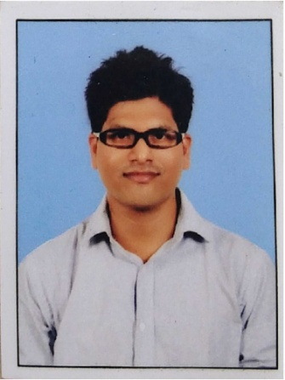

Name: Vijay Acharya

Address: “Surabhi” Bhaskara Colony

Shivagirinagara

Kulai Hosabettu

Mangalore -575019

Karnataka

India

E-mail ID:vijay1990acharya@gmail.com

Phone Number: +91 9449039989

0824-2406833

**ACADEMIC DETAILS**

* M.Sc. in Analytical Chemistry(2014) from St. Aloysius College, Mangalore with 59.88%
* B.Sc. (PCM) (2012) from St. Aloysius College, Mangalore with 57.82%
* Diploma in Commercial Application from Manipal Institute Of Computer Education

**ORGANISATIONAL EXPERIENCE**

Presently Working in **JBF Petrochemicals Ltd** (From May 2017)

Worked as Quality Control Executive

Job Description

* Routine day-to-day activities conducted in laboratory including method development, validation, and study of sample analysis of DM, CWR, Boiler, ETP, Raw material, Diesel, Lube Oil, Paraxylene, Coal, and Biomass.
* Implementing quality measures such as ASTM for continual improvement in the reports ensuring higher customer satisfaction matrices interface and executing Product Quality Assurance
* Creating and maintaining documents.
* Evaluating, developing and implementing laboratory procedures, techniques and protocols; investigating technical problems and taking corrective action
* Ensured complete in-process quality control and continuous improvement in calibration and daily factor capabilities, foreseeing performance bottlenecks and taking corrective measures to avoid the same
* Calibration of Standard industrial analytical instruments of HPLC, Gas Chromatography,TOC,Capillary Electrophoresis, X-ray Fluorescence,DO,Digital Density meter,KFTitrator,Potentiometer and Moisture Analyser.
* Trained my team regarding various plant process, analytical instrument handling, standardisation, calibration.
* Certifiying acid and base raw material based on ISO

Worked in **Total Oil India f**or 1 year 8 months

Worked as Quality Control Executive

Job Description

* Calibrating the GC by LPG calibration cylinder and propane canister.
* Determining the Density, Copper Corrosion and H2S.
* Determining the assay of LPG through GC
* LPG Cargo Ships sample analysis from harbour.
* Preparing Dibenzothiophene standard series for calibration of Total Sulphur batch managed by the lab.
* Determining the total sulphur present in LPG by Total Sulphur
* Implementing quality measures such as ISO & ISSRS and IMS & ASTM for continual improvement in the reports ensuring higher customer satisfaction matrices interface and executing Product Quality Assurance
* Evaluating, developing and implementing laboratory procedures, techniques and protocols; investigating technical problems and taking corrective action
* Acting as liaison for vendors of laboratory equipment and supplies; evaluating, testing, recommending, implementing and initiating purchase of approved equipment and supplies
* Managing gas chromatography operations, total volatile sulphur machine & other analytical instruments and maintaining equipment to assure proper functioning.

**ACADEMIC PROJECT**

* Project Guide :Dr Richard Gonsalves

Bicyclic Compound (Anti-Microbial Drug)

Derivatives of substituted Quinoline has been prepared by us during the academic year 2013-2014

**IT SKILLS**

* Tally ERP 9 ,C programming,HTMLand Internet Applications

**PERSONAL DETAILS**

Father Name: P Jagadish Acharya

Date of Birth: 9th June 1990

Languages Known: English, Kannada, Tulu and Hindi

Address: Surabhi House, Hosabettu, Mangalore, Taluk D.K. – 575019

Hobby Reading books, Listening Music

Yours faithfully,

Vijay Acharya